**Raspberry Pi 3B install win10 IOT operating system**

**1. Essential tool**

     1. Raspberry Pi 3B board

      2.Windows 10 IOT Core Insider Preview

      3.Windows 10 IOT Core Edition Dashboard

      4. Memory card (recommended 8G or more)

      5.HDMI display (can be connected to VGA display via HDMI to VGA cable)

**2.Download and install some software**

2.1) Download Windows 10 IoT Core Dashboard (write system image tool)

<https://developer.microsoft.com/zh-cn/windows/iot/Downloads.htm>

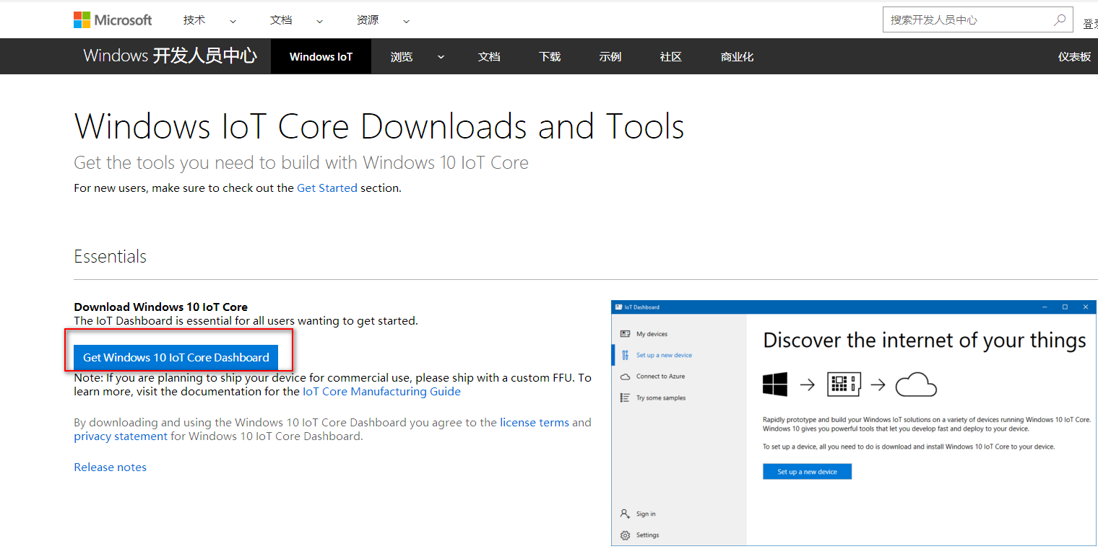

After the download is complete, you need to install it.

2.2) Download Windows 10 IoT Core Insider Preview

<https://developer.microsoft.com/zh-cn/windows/iot/Downloads.htm> 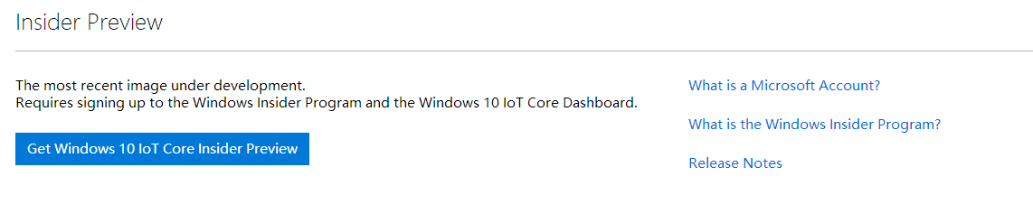

Note: Downloading win10 IoT requires a Microsoft account and has a preview version of the experience qualification, which is more troublesome. In this directory of this document, we have provided the image of the win10 IOT system that has been downloaded. 2017-09-05_165338

We need to decompress the win10 IOT system image to generate the following icon:

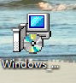

Finally, you need to click on the installation, it will automatically generate a series of files under the C drive of your computer.

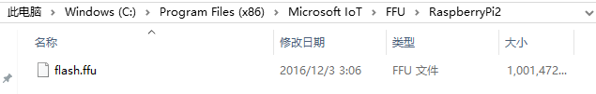

It contains the installation image of win10 iot flash.ffu.

**3. Write the image file to the memory card**

1. Open our previously installed windows 10 IOT core version of the dashboard software for writing.

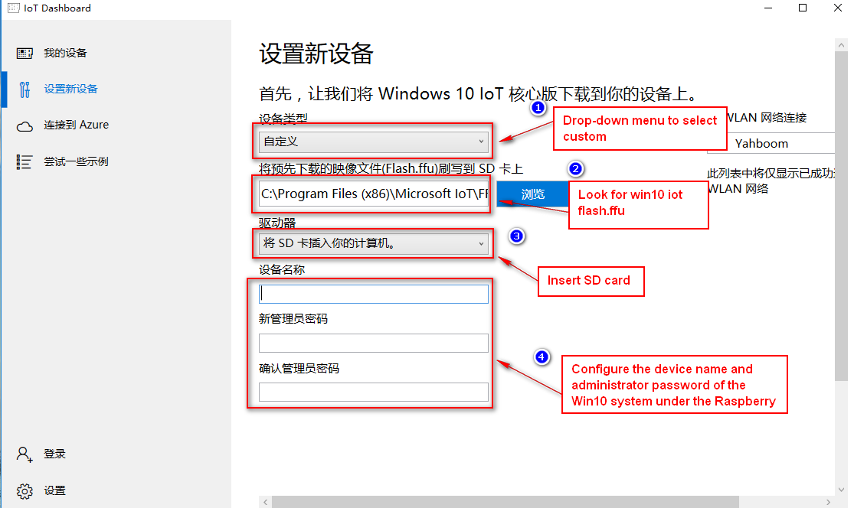

Then click the install button in the lower right corner.

At this point the system image begins to write:

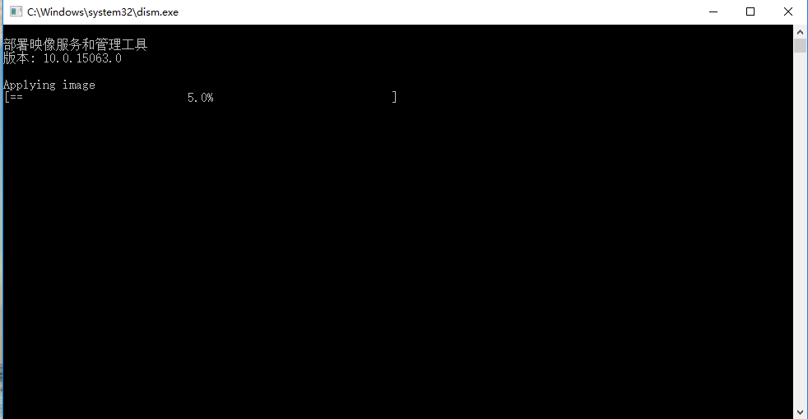

2. You need to insert the SD card into the Raspberry Pi 3 board and boot (connected to the monitor)

The following screen will appear:

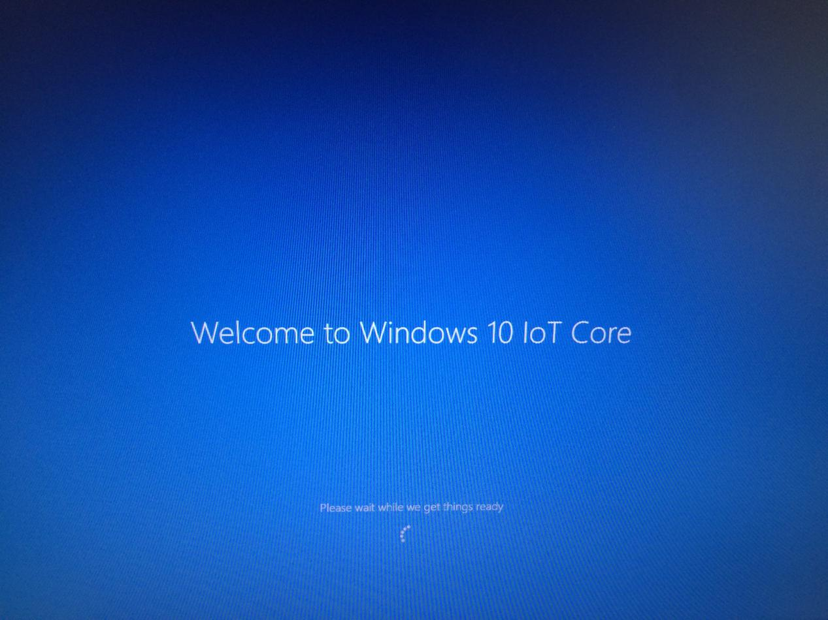

1. You can set language.

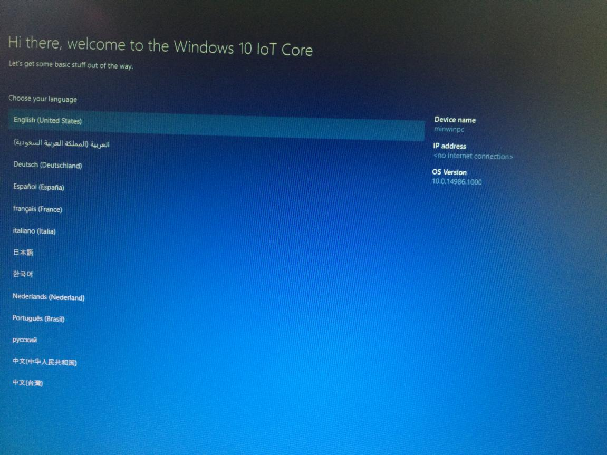

1. You need to connect to WIFI and enter system interface.

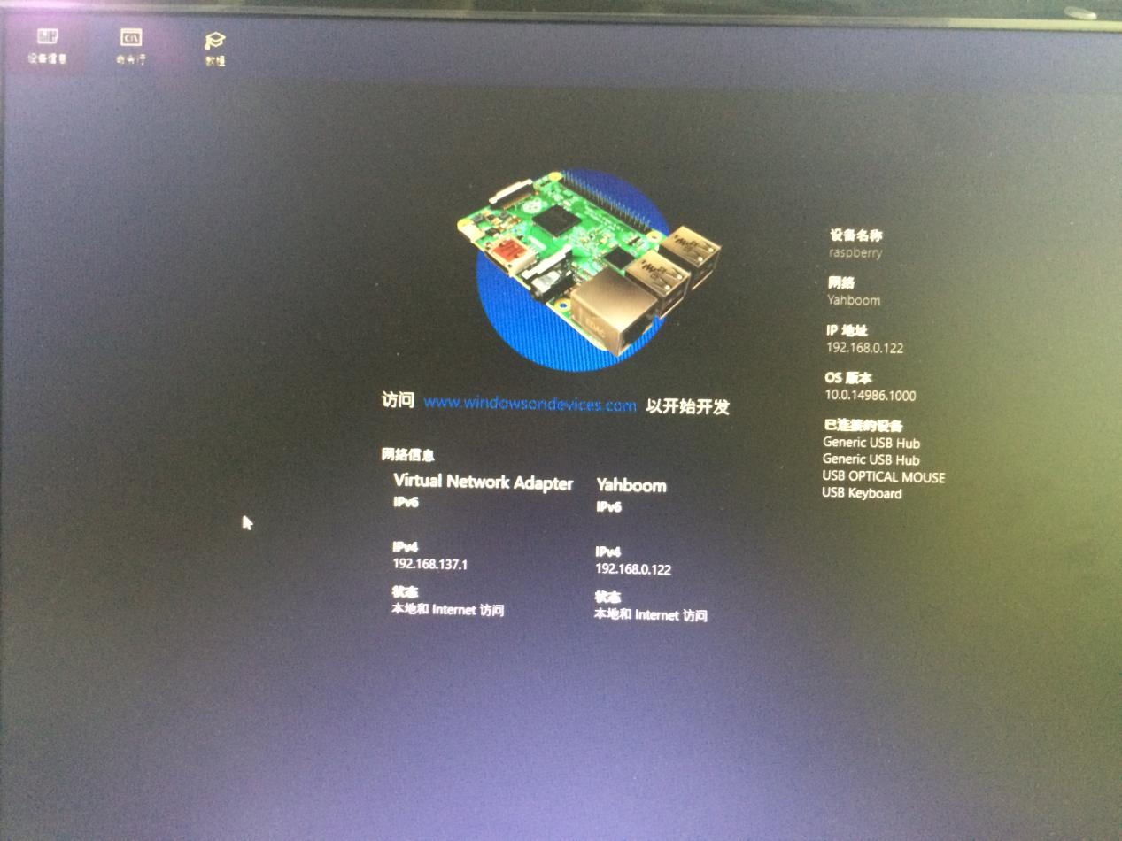

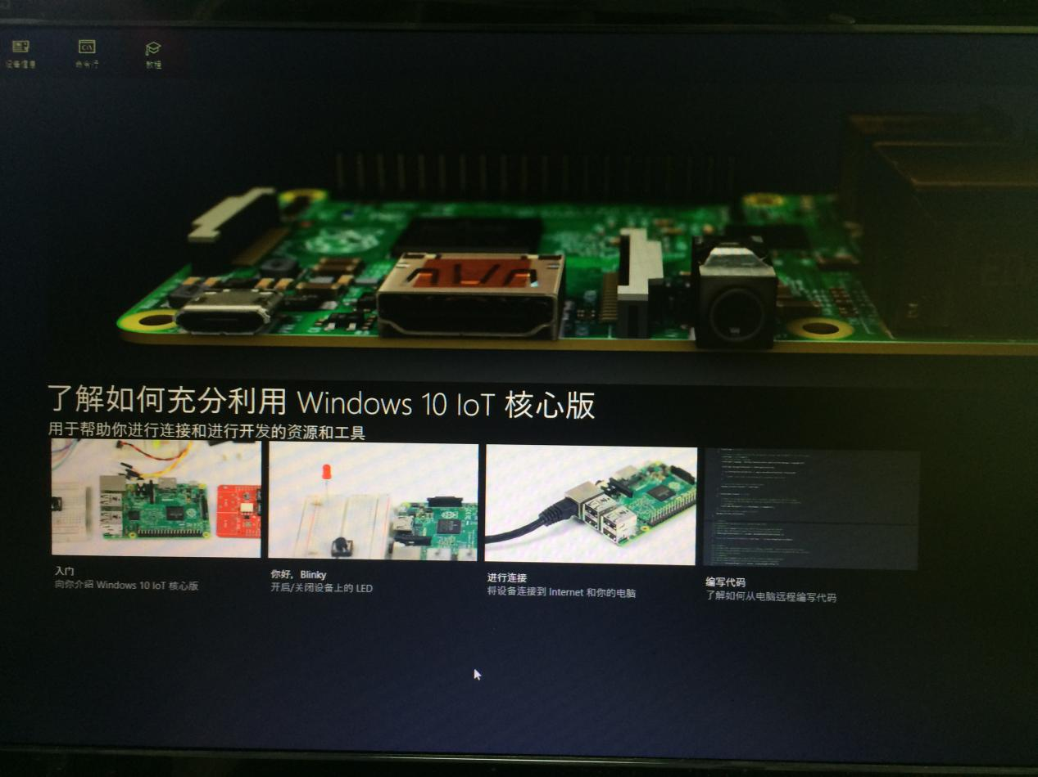

After the above steps, the Raspberry win10 system is successfully installed.